This alarmi is issued when the” type of product” (fig.1) not corrispond with the balluf head.

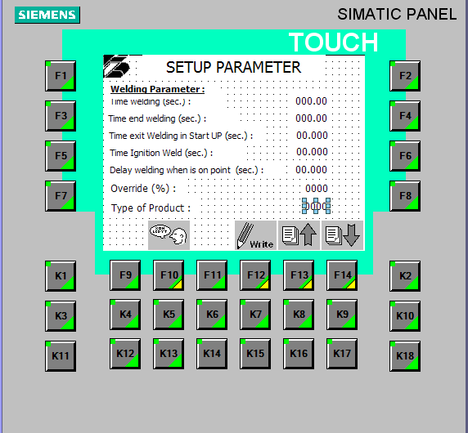

For examle if the number of vanesi s 11 then the balluff head accept value from 11 to 15. If the alarmi is occasional i hope that problemi is the balluff.

You can check the correct functionality on the balluff page.

